- There is no difference in Confidence if the form is created with data in the fields or if the fields are blank.
- If an OMR field is blank but still shows a value of 1 with 100% confidence, redraw the OMR field including the border in the box or make sure that all borders are removed from the drawing and set the Frame setting to “Without Frame”
- If a form has many pages without fillable data and someone submits a small subset of the form with only the pages that contain the fillable data, the form will be recognized but any data after the first page (considering the filled pages are 1,19) will not be recognized.
- When text fields include borders between each character, as pictured below, OCR recognizes the vertical lines as the numeric one.
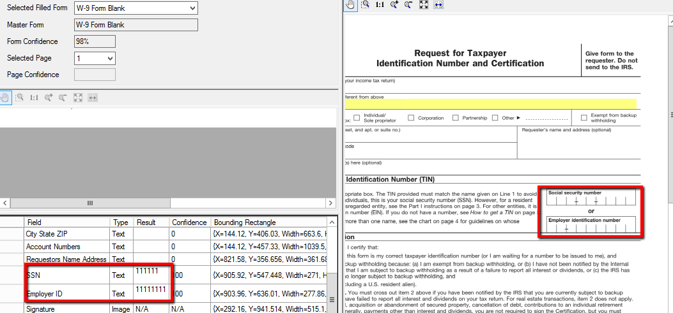
- Form Upload script cannot handle more than 50 characters in the form name without displaying an error. Form names need to be less than or equal to 50 characters.
- Image fields will retrieve an image of the signature and return a yes or no on whether or not a signature exists in a specified field.
- Fields cannot contain an (‘) in the field name or there will be an error when uploading the script.
- If form changes are made or if a new form is added, Email Receiver will need to be restarted in order for changes to take effect.
- File Load Times on first email – 7 Forms - 4 Minutes 4 Seconds
  - Background 2
  - Background_Producer_Appeal_ Form_Blank
  - Background Decline Letter 2
  - W-9 Form Blank
  - Welcome Letter
  - W92015
  - 1 - Internal Sales Agent Req Form - Fld Sales

